

**Green University of Bangladesh**

**Department of Computer Science and Engineering (CSE)**

**Faculty of Sciences and Engineering**

**Semester: (Spring, Year: 2023), B.Sc. in CSE (Day)**

**LAB REPORT NO** **:03**

**Course Title**: Artificial Intelligence Lab

**Course Code:** CSE-316 **Section:** 211D2

**Lab Experiment Name: Solve 8 queen problems**

**Student Details**

|  |  |  |
| --- | --- | --- |
| **Name** | | **ID** |
| **1.** | Md Mahdi Hasan | 211002069 |

**Lab Date : 07-05-24**

**Submission Date : 15-05-24**

**Course Teacher’s Name : Md Naimul Pathan**

|  |
| --- |
| **Lab Report Status**  **Marks: ………………………………… Signature:.....................**  **Comments:.............................................. Date:..............................** |

1. **TITLE:** Solve 8 queen problems
2. **OBJECTIVES:** N - Queens problem is to place n - queens in such a manner on an n x n chessboard that no queens attack each other by being in the same row, column or diagonal. The eight queens’ problem is the problem of placing eight queens on an 8×8 chessboard such that none of them attack one another (no two are in the same row, column, or diagonal).
3. **PROCEDURE:**

**Problem Statement**

* Place eight queens on an 8×8 chessboard.
* No queen should be able to attack any other queen.
* A queen can attack any piece in the same row, column, or diagonal.

## **Backtracking Approach**

1. Start in the leftmost column.
2. If all queens are placed, then return true.
3. Try all rows in the current column. For each row, if the queen can be placed safely in this row, then mark this cell and try to solve the problem recursively for the rest of the columns.
4. If placing the queen in the current row and proceeding to solve the rest of the problem leads to a solution, then return true.
5. If placing a queen in any row in the current column and proceeding with this placement does not lead to a solution, then backtrack and return false.
6. If all rows have been tried and none worked, return false to trigger backtracking.
7. **IMPLEMENTATION:**

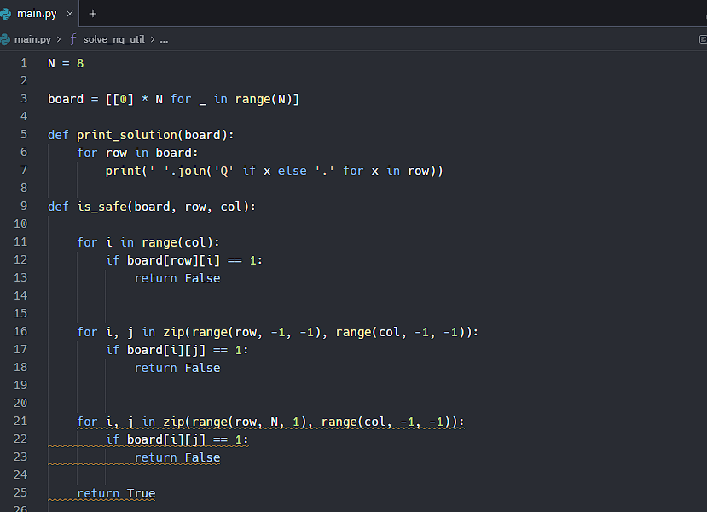

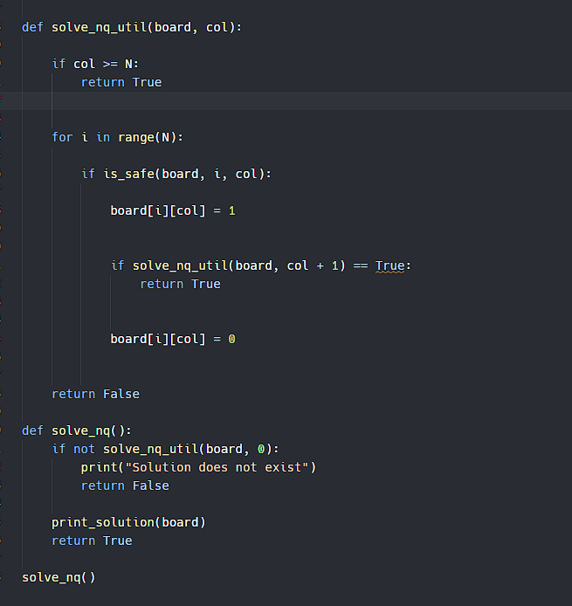

**5. OUTPUT:**

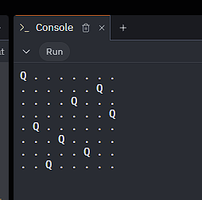

**6. ANALYSIS AND DISCUSSION**: The 8 Queens Problem is a quintessential example in computer science, illustrating the profound concept of backtracking. Studying this problem is crucial as it fosters a deep understanding of algorithmic design and enhances problem-solving skills, pivotal for tackling complex computational problems.